BRAIN TUMOR CLASSIFICATION USING 3 DIFFERENT DEEP LEARNING MODELS

Selva Karthik, Achuthan, Dr. Dennis Anand

* ***ABSTRACT:***

The human brain, which serves as the control center for all the body’s organs, is a highly developed organ that enables a person to adapt to and withstand various environmental situations. The human brain allows people to express themselves in words, carry out activities, and express thoughts and feelings. However, the delicate balance of this vital organ can be disrupted by conditions like brain tumors, which have the potential to severely impair bodily functions, cognition, and even diminish a person’s ability to perform everyday tasks, leading to a complete breakdown of their physical and mental well-being.

Brain tumors can be divided into several categories depending on the kind, place of origin, pace of development, and stage of progression; as a result, tumor classification is crucial for targeted therapy. Scholars have explored algorithms for detecting and classifying brain tumors, focusing on precision and efficiency. Deep learning methodologies are being used to create automated systems that can diagnose or segment brain tumors with precision and efficiency, particularly in brain cancer classification.

This approach facilitates three unique approaches namely ***EfficientNetB4, Noval Hybrid Model (Vision Transformers + EfficientNetB4) and a Custom 2D Convolutional Neural Network***. These models demonstrated praiseworthy performance, yielding a remarkable validation accuracy of ***99.76%, 99.14% and 93.79%*** respectively. A comparative study on various models developed for the same purpose, the results indicate our model outperforms other existing models.

**EfficientNetB4** – 97%

Source: <https://www.nature.com/articles/s41598-024-52823-9>

**2D CNN** – 93.30%

Source: <https://www.mdpi.com/1999-4893/16/4/176>

**Best Model till date:** **Caps-VGGNet** – 99.6%

Source: <https://ieeexplore.ieee.org/stamp/stamp.jsp?arnumber=10162199>

* ***INTRODUCTION:***

A brain tumor is a growth of cells in the brain or near it. Brain tumors can happen in the brain tissue and nearby. Nearby locations include nerves, the pituitary gland, the pineal gland, and the membranes that cover the surface of the brain. Brain tumors can begin in the brain. These are called primary brain tumors. Sometimes, cancer spreads to the brain from other parts of the body. These tumors are secondary brain tumors, also called metastatic brain tumors.

Many different types of primary brain tumors exist. Some brain tumors aren't cancerous. These are called noncancerous brain tumors or benign brain tumors. Noncancerous brain tumors may grow over time and press on the brain tissue. Other brain tumors are brain cancers, also called malignant brain tumors. Brain cancers may grow quickly. The cancer cells can invade and destroy the brain tissue. Brain tumor treatment options depend on the type of brain tumor you have, as well as its size and location. Common treatments include surgery and radiation therapy.

There are several types of brain tumors which include:

1. **Malignant Brain tumors:**

* Gliomas and related brain tumors
* Embryonal tumors
* Germ cell tumors
* Pineal tumors

1. **Benign Brain tumors:**

* Choroid plexus tumors
* Meningiomas
* Pituitary tumors
* Nerve tumors

In this scope of our Paper we have included three types of brain tumors namely Gliomas, Meningioma and Pituitary in the dataset.

With over 300,000 cases reported annually on a worldwide basis, brain tumors are a consistently pressing concern for the international medical community. While some brain tumors may be benign, many can invade the normal brain and develop into brain cancer.

* Approximately 72% of all brain tumors are benign
* Approximately 28% of all brain tumors are malignant
* An estimated 67,440 will be non-malignant (benign) in 2024

Non-malignant meningiomas are the most commonly occurring primary non-malignant brain tumors, accounting for 39.7% of all tumors and 55.4% of all non-malignant tumors

* An estimated 26,940 will be malignant in 2024

Glioblastoma is the most commonly occurring primary malignant brain tumor, accounting for 14.2% of all tumors and 50.1% of all malignant tumors

* ***MATERIALS AND METHODS:***
* Experimental Setup:

The proposed architectures are implemented using Python 3.12 software on

* **Google Colab (Free Version):**

**CPU:** Intel Xeon CPU with 2 virtual CPUs

**RAM:** 13GB

**GPU:** T4 GPU (16GB Memory)

* **College Server:**

**CPU:** Intel(R) Xeon(R) Silver 4310 CPU @ 2.10GHz

**RAM:** 256GB

**GPU:** NVIDIA A100 Tensor Core GPU (40GB Memory)

* **The libraries used are:**
* TensorFlow/Keras or PyTorch for building and training deep learning models.
* OpenCV or PIL for image processing.
* scikit-learn for additional machine learning utilities (e.g., model evaluation).
* Dataset:

The brain tumor classification dataset sourced from Kaggle.com

Link: <https://www.kaggle.com/datasets/masoudnickparvar/brain-tumor-mri-dataset>

This dataset contains **7023** images of human brain MRI images which are classified into 4 classes: **glioma**, **meningioma**, **no tumor** and **pituitary**.

|  |  |  |
| --- | --- | --- |
| **Type of Brain Tumor** | **No. of Training Images** | **No. of Testing Images** |
| **Glioma** | 1321 | 262 |
| **Meningioma** | 1399 | 306 |
| **Pituitary** | 1457 | 300 |
| **No Tumor** | 1591 | 405 |
| **Total** | **5768** | **1273** |

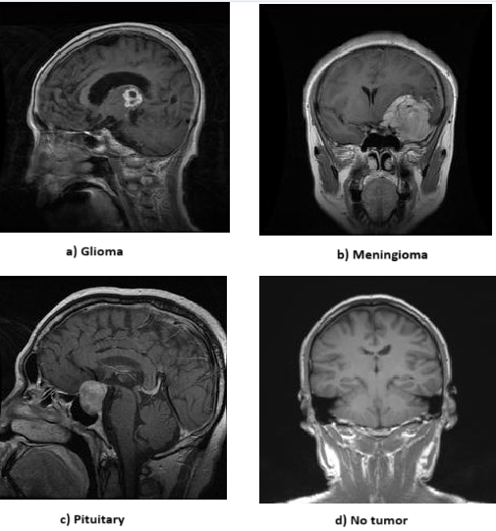

* Proposed Methodology:
* **Methodology 1: (EfficientNetB4)**

1. Dataset Description:

We used a dataset of MRI brain images that were divided into four categories:

Glioma, meningioma, pituitary and no tumor. The dataset was split into Training and testing set **(82% : 18%),** with images preprocessed to a uniform size of 240x240 pixels.

1. Data Preprocessing and Augumentation:

* **Image Rescaling:** All the images we rescaled by a factor of 1./255 to normalize the pixel values between the range of 0 and 1 to improve convergence.
* **Data Augumentation:** To reduce overfitting and to make the model generalize well, data augumentation was applied on the training set.
* **Random Rotation** (Upto 20°)
* **Random width and Height shifts** (Upto 20% of the image)
* **Shear Transformation** (upto 20%)
* **Zooming** (upto 20%)
* **Horizontal and Vertical Flipping**

1. Model Architecture:

* **Base Model: EfficentNetB4** is one of the fascinating Convolutional Neural Network Model used which was pretrained on the ImageNet dataset. EfficientNetB4 was chosen for its efficient scaling and its capability of achieving high performance even with few parameters.
* **Custom Layers:**
* **Global Average Pooling** was added to reduce the dimensionality of the feature maps.
* **A Dense** Layer with 1024 units along with **ReLU** activation function was used to capture higher-level representations.
* **L2 Regularization** was used to reduce overfitting issues**.**
* The final output was a **dense layer** with **4 units** (Representing the 4 Brain Tumor Categories) and **softmax** activationfor multi-class classification

1. Model Training:

* **Loss Function:** Categorical Cross Entropy was used as the Loss function for multi-class classification.
* **Optimizer:** Adam Optimizer was used with a learning rate of 10-3
* **Callbacks:**
* **Early Stopping:** Early Stopping mechanism was used to stop the training if the validation loss did not improve after 5 consecutive epochs, preventing overfitting.
* **Model Checkpoint:** The best model was (based on validation accuracy) was saved after training for further evaluation**.**
* **Learning rate reduction:** The learning rate was reduced by a factor of 0.2 if the validation loss did not improve after 3 consecutive epochs ensuring fine-tuning.
* **Training Duration:** The model was trained for 30 epochs with a batch size of 32 on both training and testing set.

1. Evaluation:

After training, the best model evaluated was saved, with a final test accuracy of 99.06%. This model achieved a validation accuracy of **99.76%**, which indicated high generalization capabilities.

1. Schematic Architecture Diagram for EfficientNetB4:

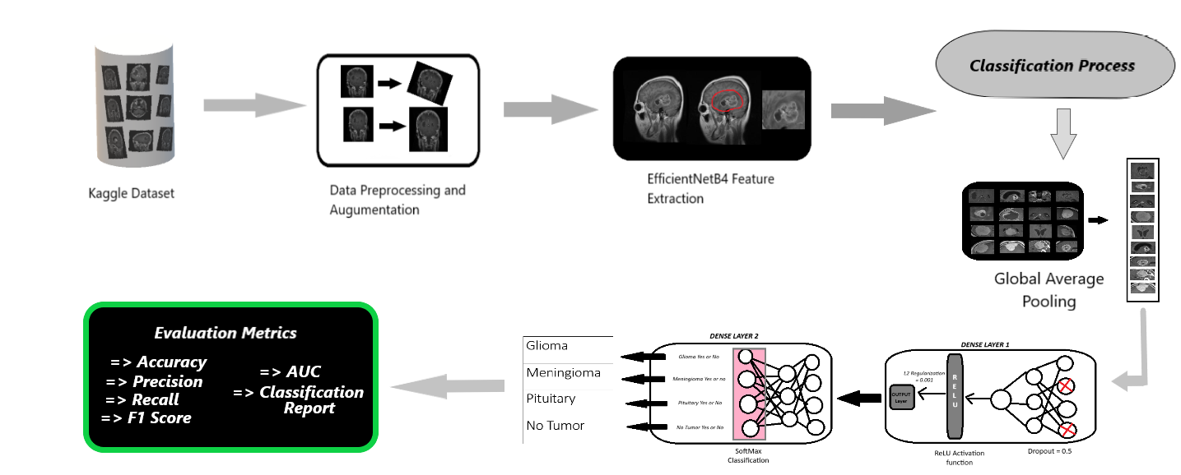

* **Methodology 2: (Vision Transformer + EfficientNetB4)**

1. Dataset Description:

We used a dataset of MRI brain images that were divided into four categories:

Glioma, meningioma, pituitary and no tumor. The dataset was split into Training and testing set **(82% : 18%),** with images preprocessed to a uniform size of 224x224 pixels.

1. Data Preprocessing and Augumentation:

* **Image Rescaling:** All the images we rescaled by a factor of 1./255 to normalize the pixel values between the range of 0 and 1 to improve convergence.
* **Data Augumentation:** To reduce overfitting and to make the model generalize well, data augumentation was applied on the training set.
* **Random Rotation** (Upto 20°)
* **Random width and Height shifts** (Upto 20% of the image)
* **Shear Transformation** (upto 20%)
* **Zooming** (upto 20%)
* **Horizontal and Vertical Flipping**
* **Brightness Range** (range 0.8 to 1.2)

1. Model Architecture:

* **Base Model: Vision Transformer (ViT)** was used (ViT B-32 Architecture)which was pretrained on the ImageNet dataset. EfficientNetB4 was chosen for its powerful long-range dependencies and its effectiveness in handling high dimensional image data.
* **Custom Layers:**
* **Global Average Pooling** was added to reduce the dimensionality of output from ViT model.
* **A Dense** Layer with 1024 units along with **ReLU** activation function was used to capture higher-level representations.
* **Dropout rate** of 0.5 was used to prevent overfitting
* **L2 Regularization** was used to reduce overfitting issues**.**
* The final output was a **dense layer** with **4 units** (Representing the 4 Brain Tumor Categories) and **softmax** activationfor multi-class classification

1. Model Training:

* **Loss Function:** Categorical Cross Entropy was used as the Loss function for multi-class classification.
* **Optimizer:** Adam Optimizer was used with a learning rate of 10-4
* **Callbacks:**
* **Early Stopping:** Early Stopping mechanism was used to stop the training if the validation loss did not improve after 5 consecutive epochs, preventing overfitting.
* **Model Checkpoint:** The best model was (based on validation accuracy) was saved after training for further evaluation**.**
* **Learning rate reduction:** The learning rate was reduced by a factor of 0.2 if the validation loss did not improve after 3 consecutive epochs ensuring fine-tuning.
* **Training Duration:** The model was trained for 30 epochs with a batch size of 32 on both training and testing set.

1. Evaluation:

After training, the best model evaluated was saved, with a final test accuracy of 98.59%. This model achieved a validation accuracy of **99.14%**, which indicated high generalization capabilities.

1. Schematic Architecture Diagram for Hybrid Model:

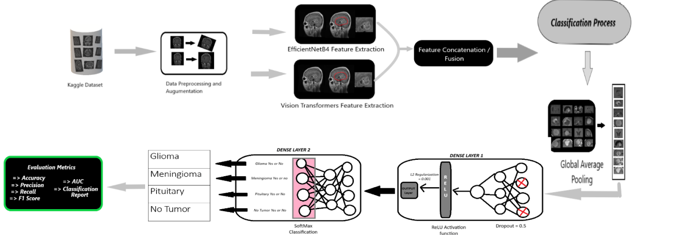

* **Methodology 3: (Custom 2D CNN Architecture)**

1. Dataset Description:

We used a dataset of MRI brain images that were divided into four categories:

Glioma, meningioma, pituitary and no tumor. The dataset was split into Training and testing set **(82% : 18%),** with images preprocessed to a uniform size of 224x224 pixels.

1. Data Preprocessing and Augumentation:

* **Image Rescaling:** All the images we rescaled by a factor of 1./255 to normalize the pixel values between the range of 0 and 1 to improve convergence.
* **Data Augumentation:** To reduce overfitting and to make the model generalize well, data augumentation was applied on the training set.
* **Random Rotation** (Upto 20°)
* **Random width and Height shifts** (Upto 20% of the image)
* **Shear Transformation** (upto 20%)
* **Zooming** (upto 20%)
* **Horizontal and Vertical Flipping**

1. Model Architecture:

* **Base Model:** We developed a custom **2D Convolution Neural Network** designed specially for Brain Tumor Classification.
* **Custom Layers:**
* **Convolutional Layer 1:** 32 filters with a kernel size of 5x5, followed by ReLU activation.
* **MaxPooling Layer 1:** 2x2 pooling to downsample the feature maps.
* **Convolutional Layer 2:** 64 filters with a kernel size of 5x5, followed by ReLU activation.
* **MaxPooling Layer 2:** 2x2 pooling for further downsampling.
* **Convolutional Layer 3:** 128 filters with a kernel size of 5x5, followed by ReLU activation.
* **MaxPooling Layer 3:** 2x2 pooling.
* **Flatten Layer:** Flattens the 3D output to a 1D array.
* **Fully Connected Layer:** 128 units with a sigmoid activation function for capturing complex representations.
* **Output Layer:** 4 units with softmax activation for multi-class classification representing the four brain tumor categories.

1. Model Training:

* **Loss Function:** Categorical Cross Entropy was used as the Loss function for multi-class classification.
* **Optimizer:** Adam Optimizer was used with a learning rate of 10-3
* **Training Duration:** The model was trained for 50 epochs with a batch size of 32 on both training and testing set.

1. Evaluation:

After training, the best model evaluated was saved, with a final test accuracy of 90.73%. This model achieved a validation accuracy of **92.93%**, which indicated high generalization capabilities.

1. Schematic Architecture Diagram for 2D CNN:

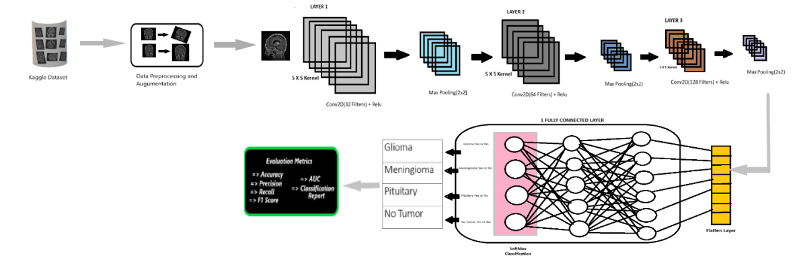

* Confusion Metrics:

The system model’s effectiveness was evaluated using confusion metrics, which categorize accurate and erroneous prognostications into four distinct classifications

* True positive (TP) occurs when both the predicted and actual outcomes are positive;
* False positive (FP) occurs when a forecast predicts a positive outcome, but the actual

outcome is negative;

* True negative (TN) occurs when both the observed outcome and prognostication

are negative;

* False negative (FN) occurs when a prediction incorrectly predicts a negative outcome,despite the actual result being positive

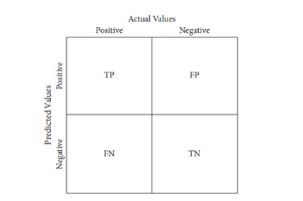

**Confusion Metrics**

* Performance Metrics:

Evaluation metrics should constantly be performed, utilizing the system’s all open elements to assess the viability of brain tumor discovery

* **Accuracy (ACC): Accuracy** measures the proportion of correctly predicted outcomes (both positives and negatives) out of the total predictions.

**Accuracy =**

* **Specificity (SPC): Specificity** indicates the ability of the model to correctly identify negative cases (i.e., non-tumor cases).

**Specificity =**

* **Sensitivity (SEN) or Recall (REC)**: **Recall** measures the model's ability to correctly identify positive cases (i.e., tumor cases).

**Recall =**

* **Precision (PREC)**: **Precision** is the proportion of true positive predictions out of all predicted positives, indicating the model's reliability.

**Precision =**

* **F1 Score (F-Score): F1 Score** is the harmonic mean of precision and recall, providing a balanced evaluation of the model.

**F1-Score = 2 x x 100%**

* **Area Under the Curve (AUC): AUC** quantifies the model's ability to distinguish between positive and negative cases across various thresholds.

**AUC =**

* ***RESULTS AND DISCUSSIONS:***

1. **OVERVIEW OF MODELS PERFORMANCE:**

In this whole research, we developed and evaluated three distinct Brain Tumor Classification models:

* 1. **Model 1: (EfficientNetB4)**

Validation Accuracy: 99.76%

Validation Loss: 0.2636

* 1. **Model 2: (Hybrid Model – ViT + EfficientNetB4)**

Validation Accuracy: 99.14%

Validation Loss: 0.1938

* 1. **Model 3: (Custom 2D CNN):**

Validation Accuracy: 92.93%

Validation Loss: 0.1792

Each model was trained on the same dataset comprising of MRI images which was classified into four categories: **Glioma, Meningioma, Pituitary and No tumor**. The models were evaluated based on various metrics like Accuracy, Precision, Recall, F1-Score and AUC.

1. **PERFORMANCE METRICS:**
2. **Model 1: (EfficientNetB4)**

| **Class** | **AUC Score** |
| --- | --- |
| Glioma | 1.0000 |
| Meningioma | 0.9996 |
| No Tumor | 1.0000 |
| Pituitary | 0.9995 |

| **Metric** | **Value** |
| --- | --- |
| Test Loss | 0.263600 |
| Test Accuracy | 0.99764335 |

* *Classification Report:*

| **Class** | **Precision** | **Recall** | **F1-Score** | **Support** |
| --- | --- | --- | --- | --- |
| Glioma | 1.00 | 1.00 | 1.00 | 262 |
| Meningioma | 0.99 | 0.99 | 0.99 | 306 |
| No Tumor | 1.00 | 1.00 | 1.00 | 405 |
| Pituitary | 0.99 | 1.00 | 1.00 | 300 |
| Accuracy |  |  | 1.00 | 1273 |
| Macro Avg | 1.00 | 1.00 | 1.00 | 1273 |
| Weighted Avg | 1.00 | 1.00 | 1.00 | 1273 |

* *Confusion Metrics:*

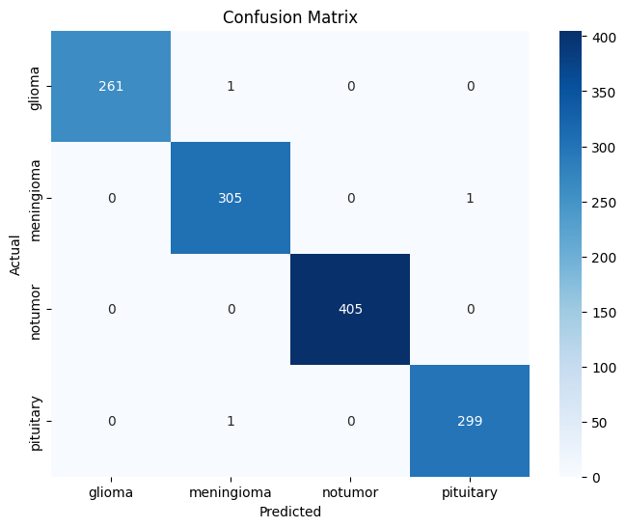

* *Accuracy and Loss Comparison with Training and Validation:*

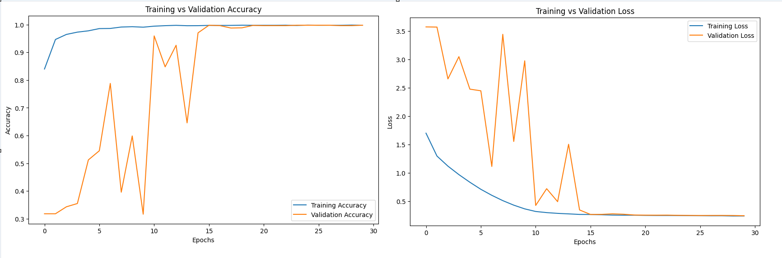

* *ROC Curve for each class:*

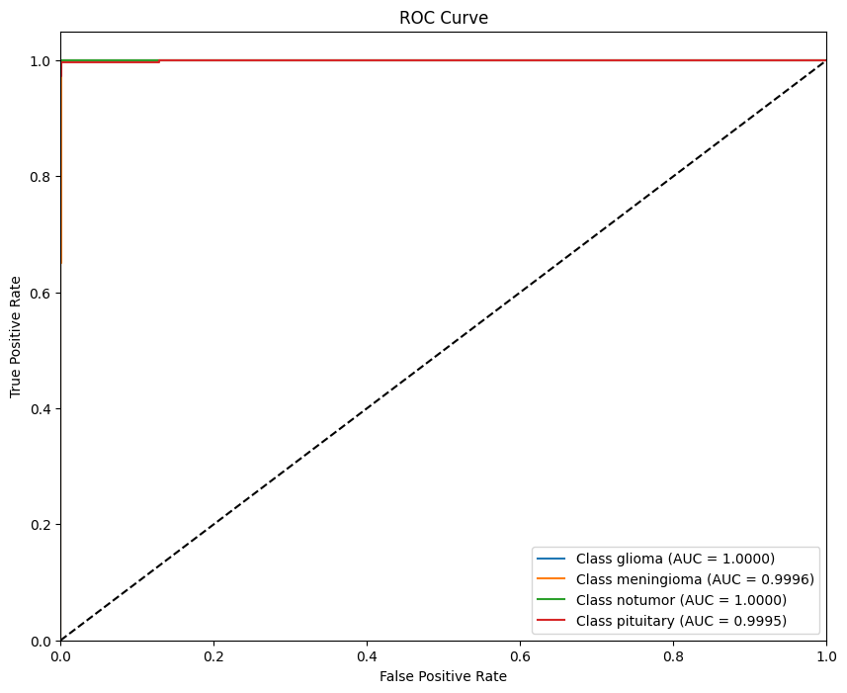

* *Precision-Recall Curve for each class:*

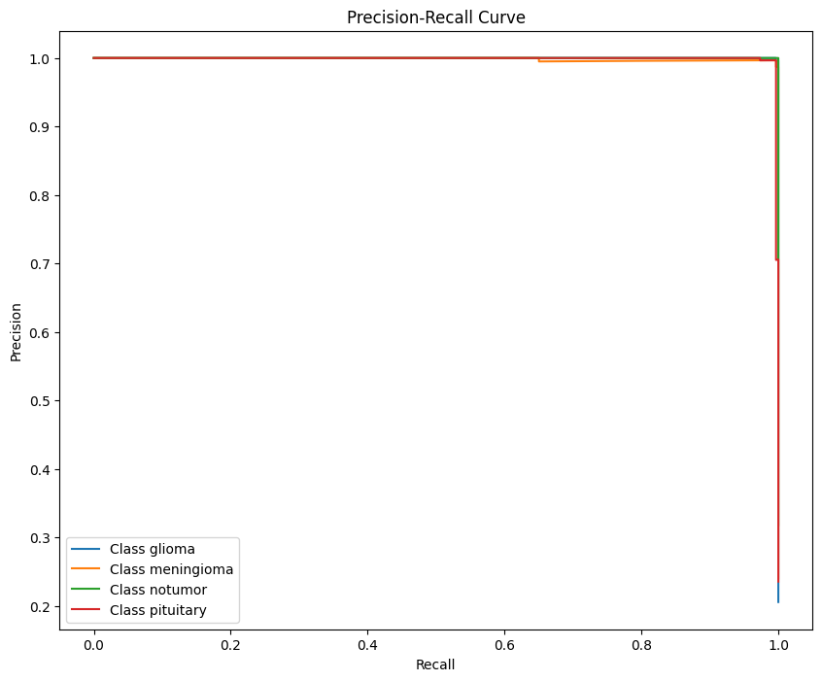

* *Class-wise Accuracy Bar Plot:*

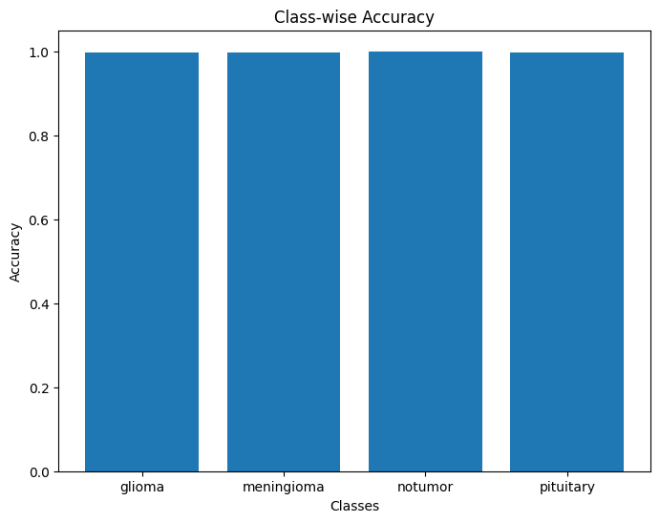

* *Learning Rate vs Loss:*

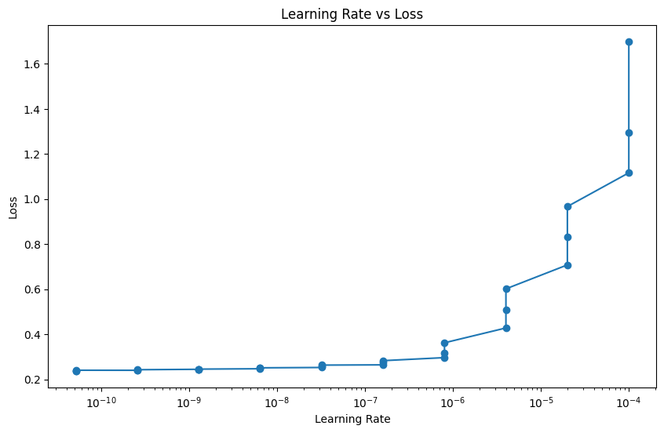

1. **Model 2: (Vision Transformer + EfficientNetB4)**

| **Class** | **AUC Score** |
| --- | --- |
| Glioma | 1.00000 |
| Meningioma | 0.9997 |
| No Tumor | 1.00000 |
| Pituitary | 0.9998 |

| **Metric** | **Value** |
| --- | --- |
| Test Loss | 0.03409804031252861 |
| Test Accuracy | 0.9960722923278809 |

* *Classification Report:*

| **Class** | **Precision** | **Recall** | **F1-Score** | **Support** |
| --- | --- | --- | --- | --- |
| Glioma | 1.00 | 1.00 | 1.00 | 262 |
| Meningioma | 1.00 | 0.99 | 1.00 | 306 |
| No Tumor | 1.00 | 1.00 | 1.00 | 405 |
| Pituitary | 0.99 | 0.99 | 0.99 | 300 |
| Accuracy |  |  | 1.00 | 1273 |
| Macro Avg | 1.00 | 1.00 | 1.00 | 1273 |
| Weighted Avg | 1.00 | 1.00 | 1.00 | 1273 |

* *Confusion Metrics:*

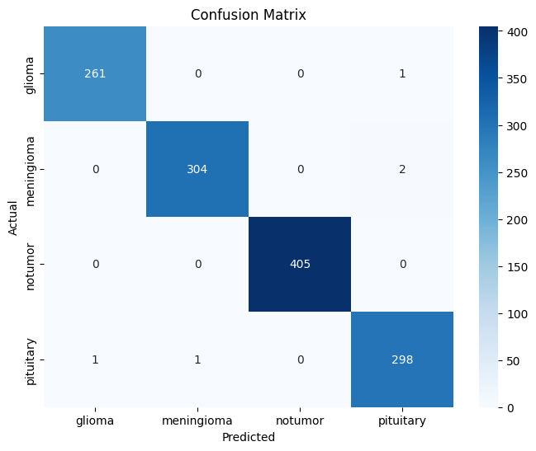

* *Accuracy and Loss Comparison with Training and Validation:*

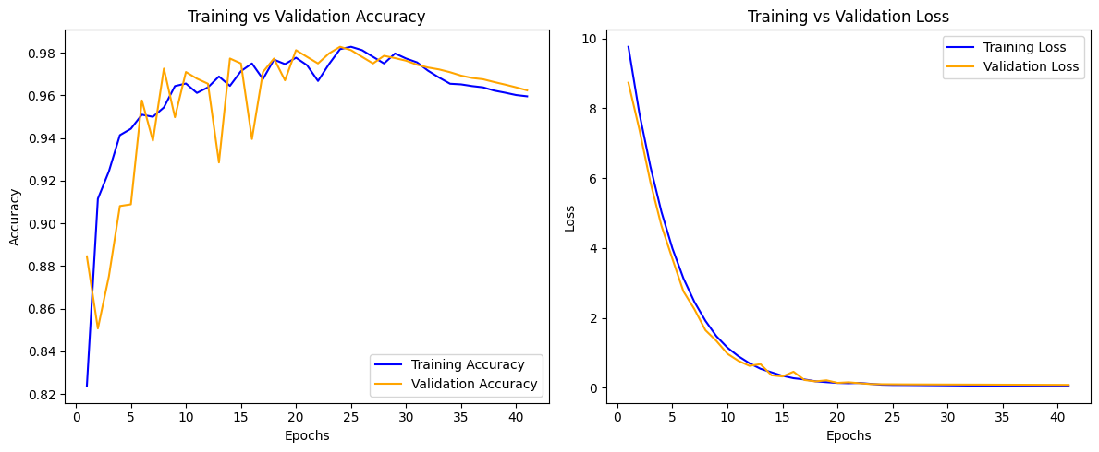

* *ROC Curve for each class:*

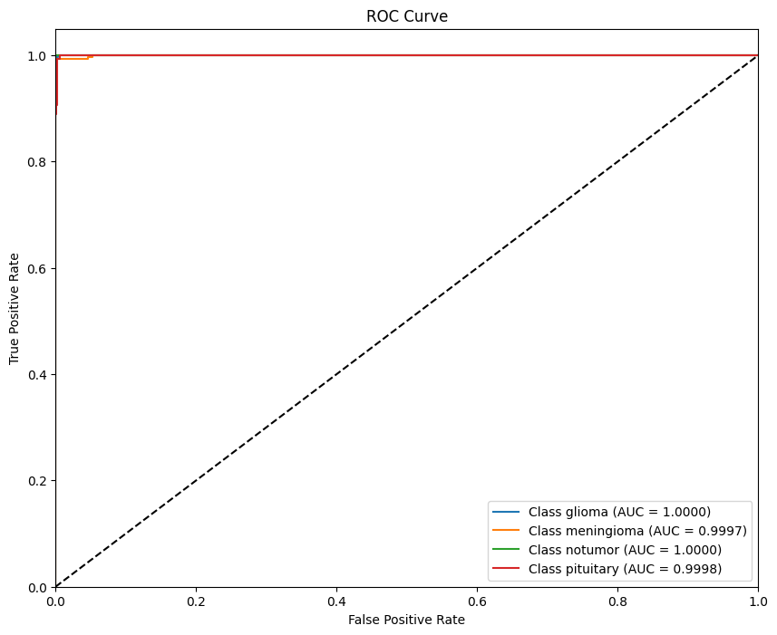

* *Precision-Recall Curve for each class:*

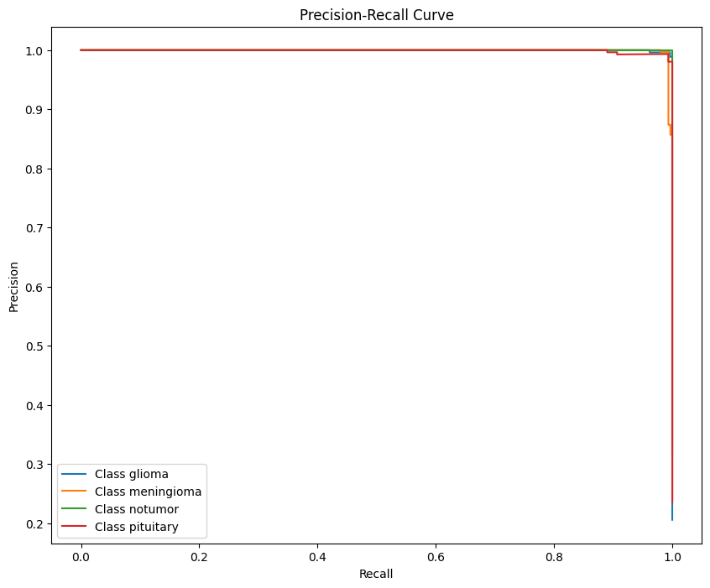

* *Class-wise Accuracy Bar Plot:*

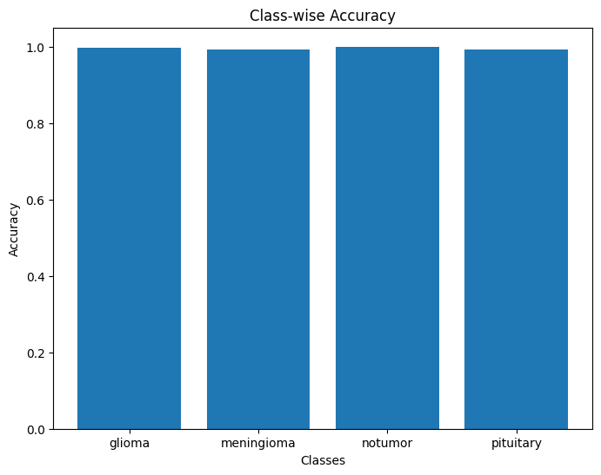

* *Learning Rate vs Loss:*

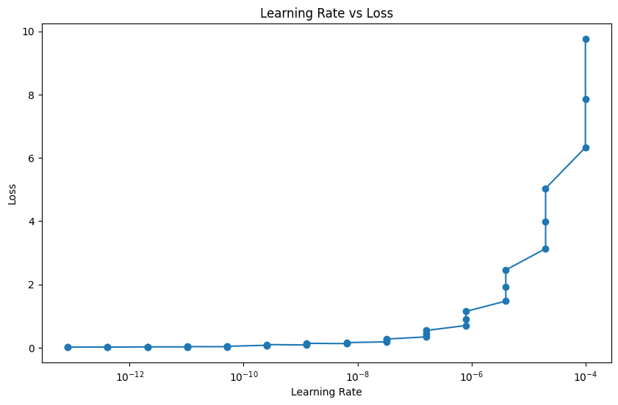

1. **Model 3: (Custom 2D Convolution Neural Network)**

| **Class** | **AUC Score** |
| --- | --- |
| Glioma | 0.9938463164729956 |
| Meningioma | 0.9739880095437002 |
| No Tumor | 0.997889287136599 |
| Pituitary | 0.9989037341555327 |

| **Metric** | **Value** |
| --- | --- |
| Test Loss | 0.1941 |
| Test Accuracy | 0.9277 |

* *Classification Report:*

| **Class** | **Precision** | **Recall** | **F1-Score** | **Support** |
| --- | --- | --- | --- | --- |
| Glioma | 0.96 | 0.90 | 0.93 | 262 |
| Meningioma | 0.92 | 0.75 | 0.83 | 306 |
| No Tumor | 0.88 | 1.00 | 0.94 | 405 |
| Pituitary | 0.94 | 0.99 | 0.96 | 300 |
| Accuracy |  |  | 0.92 | 1273 |
| Macro Avg | 0.92 | 0.91 | 0.91 | 1273 |
| Weighted Avg | 0.92 | 0.90 | 0.92 | 1273 |

* *Confusion Metrics:*

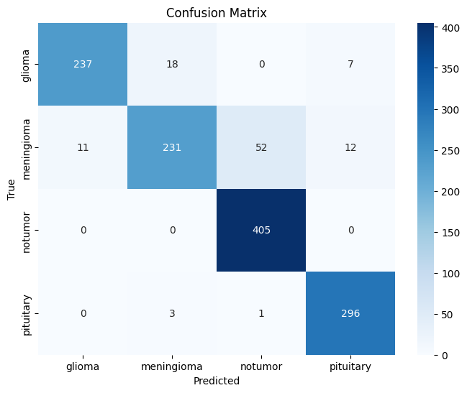

* *Accuracy and Loss Comparison with Training and Validation:*

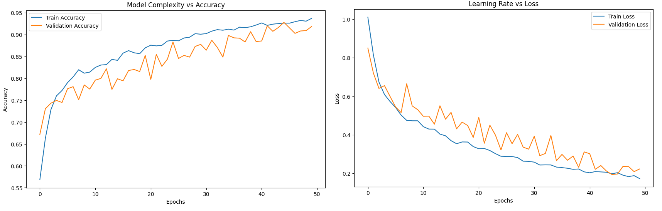

* *ROC Curve for each class:*

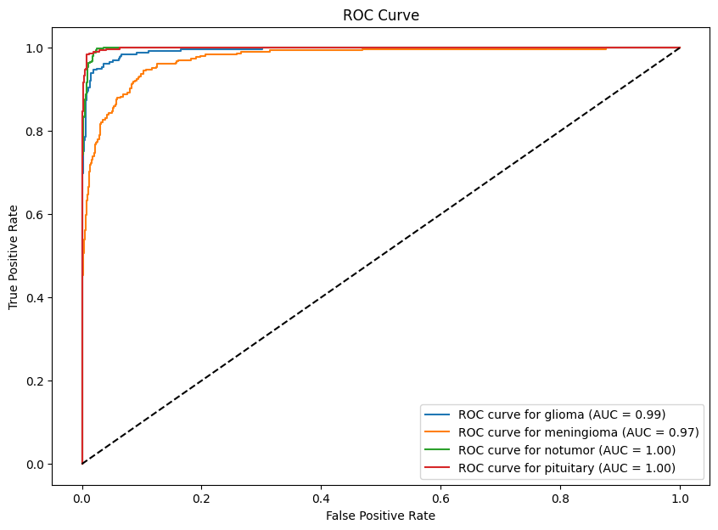

* *Precision-Recall Curve for each class:*

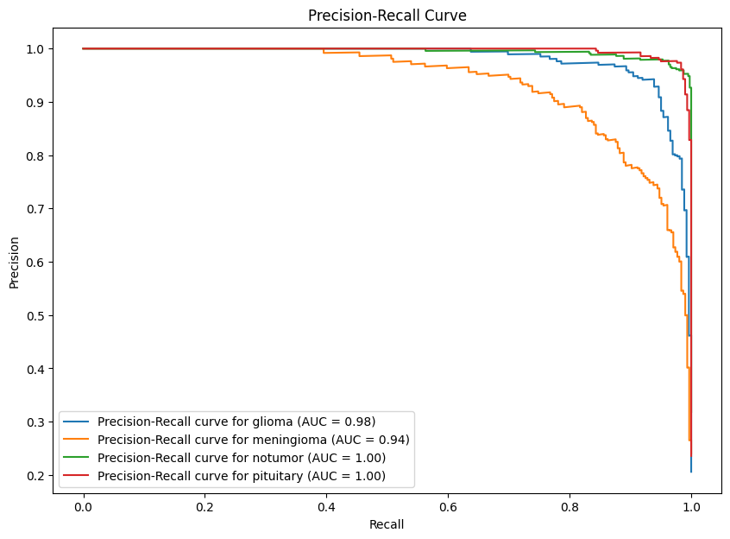

* *Class-wise Accuracy Bar Plot:*

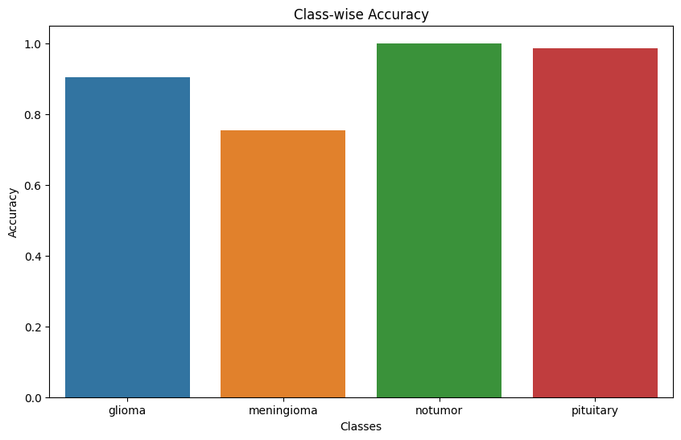

* *Learning Rate vs Loss:*

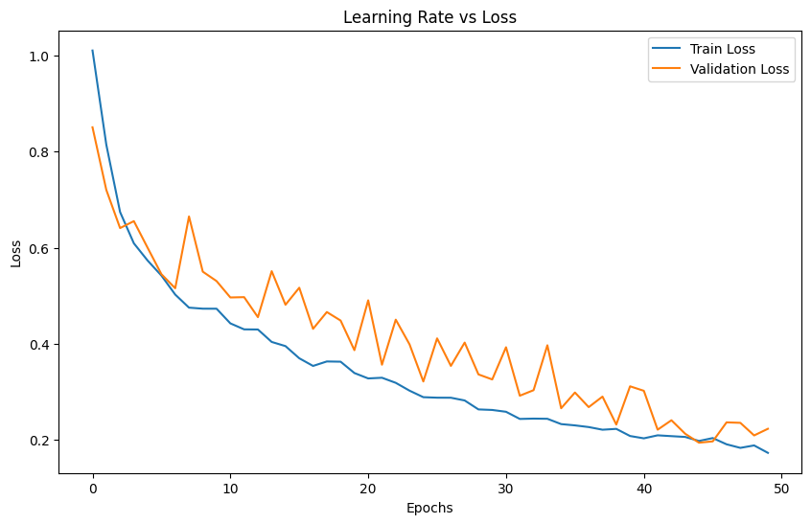

* ***CONCLUSIONS AND FUTURE WORKS:***
* ***REFERENCES:***